**Contents**

Project Proposal 2

Goals and Objectives 2

Scope and Deliverables 2

Project Scope 2

In Scope 2

Out of Scope 2

Project Deliverables 2

Project Specification and Target Audience 3

Project Schedule and milestones 3

Resources Required 3

Functional and Non-Functional Requirement 3

Functional Requirements 3

Non-Functional Requirements 4

Project Assumptions 4

Detailed Design 4

Home Page 4

Login Page 4

Admin Book Page 5

Admin Reader Page 5

Admin Sales Record Page 6

User Book Page 6

User Wishlist Page 7

Project Testing 8

Testing Scope 8

Testing Enviornment 8

Pass/Fail criteria of the test 8

User Manual 9

Introduction 9

User Activities 9

Admin Activities 9

# Project Proposal

## Goals and Objectives

The main goal of this project is to implement an online Bookshop Web Application where users can buy books. In this application there are two types admin and user. Admin can add books, edit books and delete books. Moreover, admin can edit, delete and check details for readers and create, edit, delete and check details for sales records. Further, admin has the authority to add/register new admin. User can view books, add books to the wishlist, remive from the wishlist and view the wishlist. Only registered admin and user can login the web application.

## Scope and Deliverables

## Project Scope

This is a 20 days project. Below is the in scope and out of scope items of this project

### In Scope

* Implement Admin functions like edit, delete user profiles,add, edit, delete books, create,edit, update sales records.
* Implement user functions like add books, remove books from wishlist and viewing the wishlist.
* Test all functionalities.

### Out of Scope

* Online payment and purchase is out of scope.
* Any hardware or software cost is out of scope.

## Project Deliverables

To achieve the goal of our project, we have set following deliverables:

|  |  |
| --- | --- |
| **Deliverables** | **Explanation** |
| Planning | This includes the planning and specification of the project. |
| Coding and Implemetation | This will show the coding and implememtation part of the project. |
| Testing and documentation | This will demonstrate how application it will be used and also the test details of the wev app. |
| Final written Report | This will provide the detailed report along with all detiails of goals, objectives, timeliness etc. |

## Project Specification and Target Audience

Secure login and registration by admin and user.

Add, edit, delete books by admin.

Edit, delete of readers by admin.

* Add books to wishlist by user, view books in wishlist and remove books from the wishlist.
* Create, update, edit and delete the sales records by admin.

Target audience for this web application will be any book lover who loves to read books and want to explore the new books. Starting from the age of 15 to 100 and more.

# Project Schedule and milestones

|  |  |  |
| --- | --- | --- |
| Milestone | Weeks | Deliverable(s) Completed |
| Project planning | 1-2 | * Kickoff Meeting * Project Proposal * Project Definition Document * Analysis Report |
| Iteration 1 | 2-3 | * Database Design * Front End Design |
| Iteration 2 | 3-4 | * Back End – Phase 1 * Back End – Phase 2 * Final Product |
| Iteration 3 | 3-4 | * Testing * Report and final Documentation |

# Resources Required

* Windows OS 10, 4 GB RAM, Minimum i5 processor
* ASP.Net MVC and Identity Framework

# Functional and Non-Functional Requirement

## **Functional Requirements**

* System should allow new customer to create user profile.
* System should allow all customers to update their profile.
* System should allow the admin to update the books, readers and sales record.
* System should allow admin to delete/update the user information.

## **Non-Functional Requirements**

* System should be secure.
* System should run in any browser
* System should be fast and easy to use.
* System should keep personal details of the users secured.

## **Project Assumptions**

* During the plan I made the following assumption for the application:
* User is available to provide the feedback for system
* Atleast one user has registered at the time of the implementation
* Admin has already registred and can register other person as admin later
* No registration fee

# Detailed Design

## Home Page

This is main page of the web application, which will be common for all users. This page contain home, books,reader signup, login and create shop admin menu options.



## Login Page

Login page allow register user and admin to login into the web app.

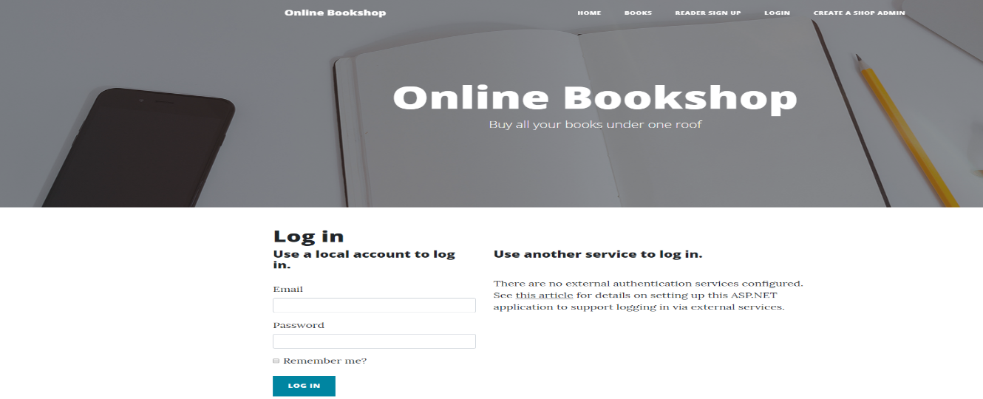

## Admin Book Page

This page will be used to show the avialble books in the onine bookshop app in admin view. Admin can add new books and edit the details of the existing books and also can delete the books.

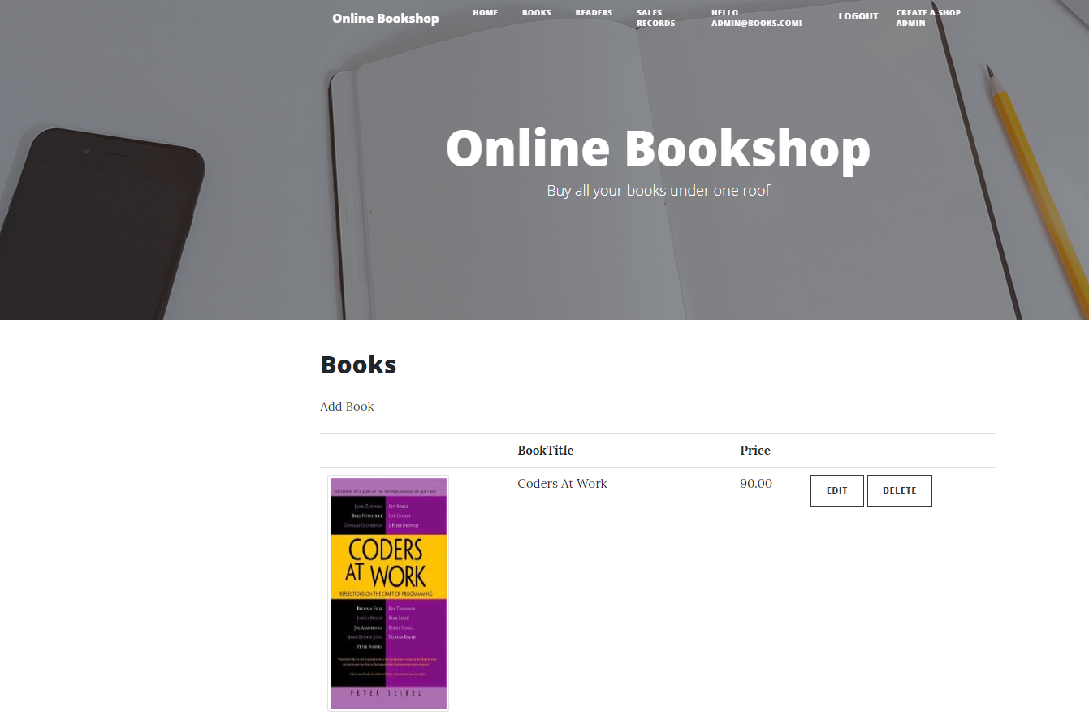

## Admin Reader Page

This page provide the information about the Readers who are registered with the online bookshop. An admin can edit, delete and view their details.

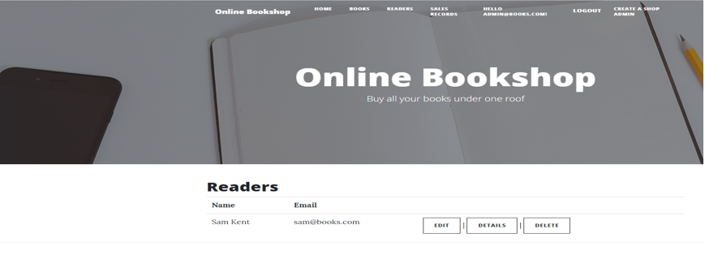

## Admin Sales Record Page

In this page admin can create, edit, delete and view details of sales records.

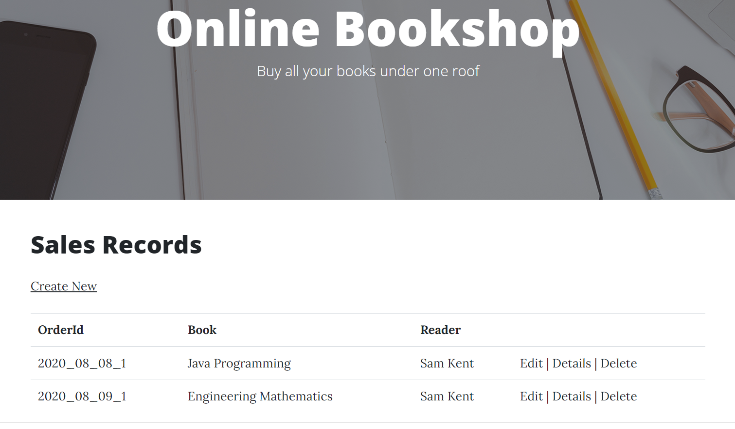

## User Book Page

In this page user can view all the available book on the bookshop also can add them to wishlist.

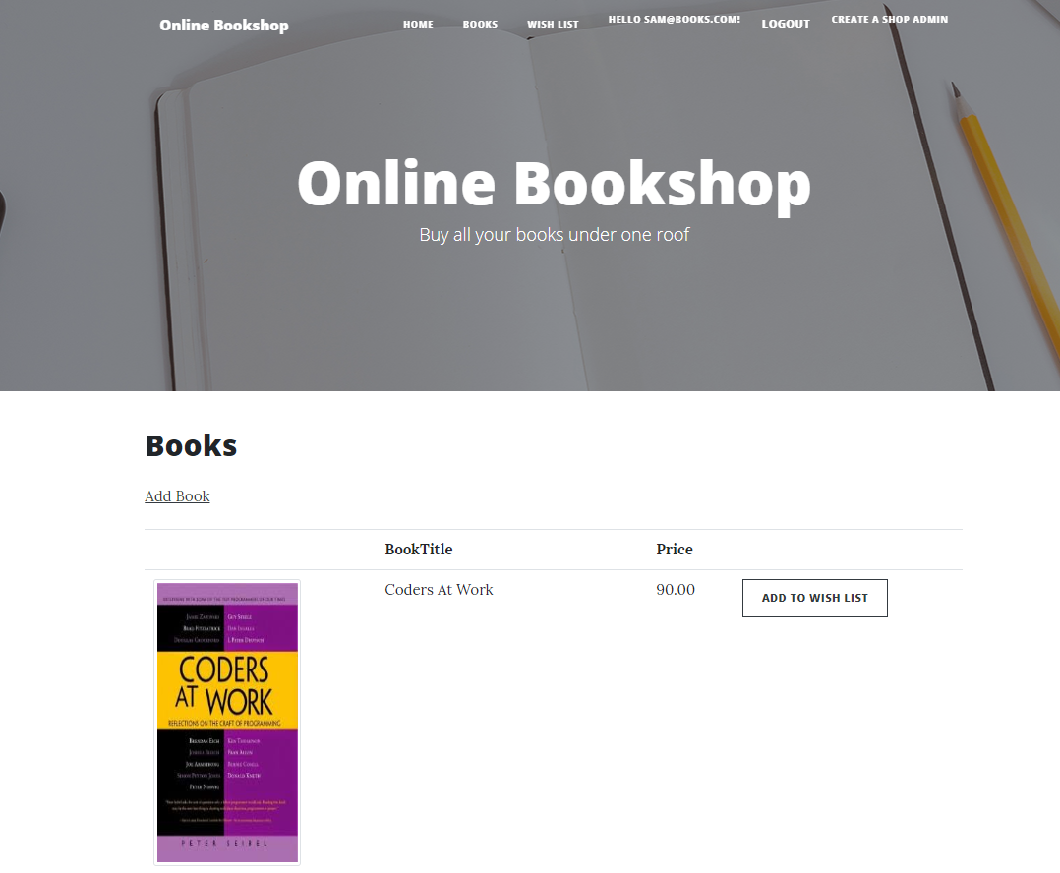

## User Wishlist Page

On this page user can view his/her books which he/she added in the wishlist and can remove books from the wishlist.

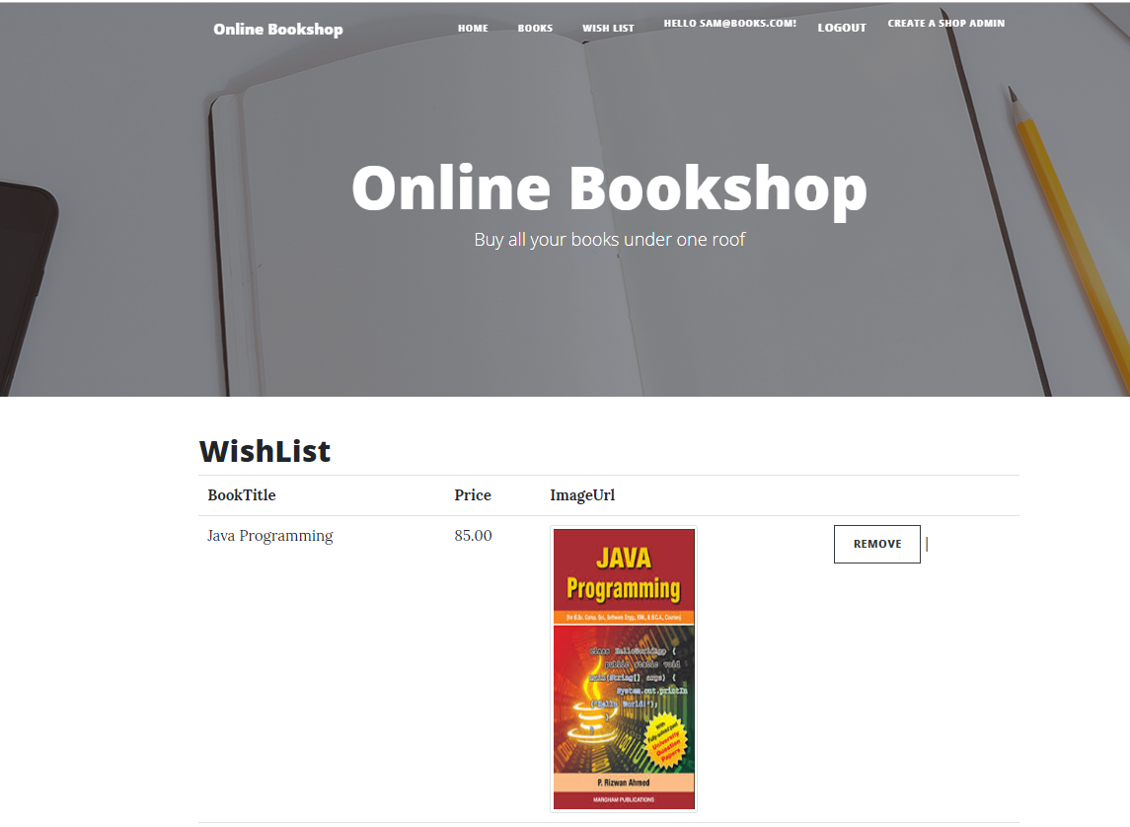

# Project Testing

## Testing Scope

As it has been mentioned before due to limited time period, we prioritized testing of only important parts of the project. In general this report will include:

* Testing of the desktop version
* Testing of the database

Testing process will include, database testing, user interface testing, system and performance testing

Aspects of testing.

* Accessibility
* Compatibility
* Functionality
* Content
* Navigation
* Performance
* Site recognition
* Usability

## Testing Enviornment

All testing will be conducted with using of stand - alone Windows 10 with using Chrome desktop

browser.

* Installed memory (RAM) 8.00 GB. System type: 64-bit Operating System, x64-based processor.
* Windows 10 and Chrome Brower.

## Pass/Fail criteria of the test

Testing process considered to be completed when the main functionality has been tested according to following pass/fail criteria:

* All tests are completed.
* Main functionality is working.
* The percentage of the competed tests are conducted without errors

# User Manual

## Introduction

In online Bookshop Web Application users can buy books. In this application there are two types admin and user. Admin can add books, edit books and delete books. Moreover, admin can edit, delete and check details for readers and create, edit, delete and check details for sales records. Further, admin has the authority to add/register new admin. User can view books, add books to the wishlist, remive from the wishlist and view the wishlist. Only registered admin and user can login the web application.

## User Activities

* Registeration
* Login/Logout
* Add books in Wishlist
* Remove books from Wishlist
* View Wishlist

## Admin Activities

* Login/Logout
* Delete/Edit and check details of Reader
* Add, edit, delete books
* Create, edit, delete and check details for sales record.